38.  Display names of employees along with their department name who have more than 20 years experience

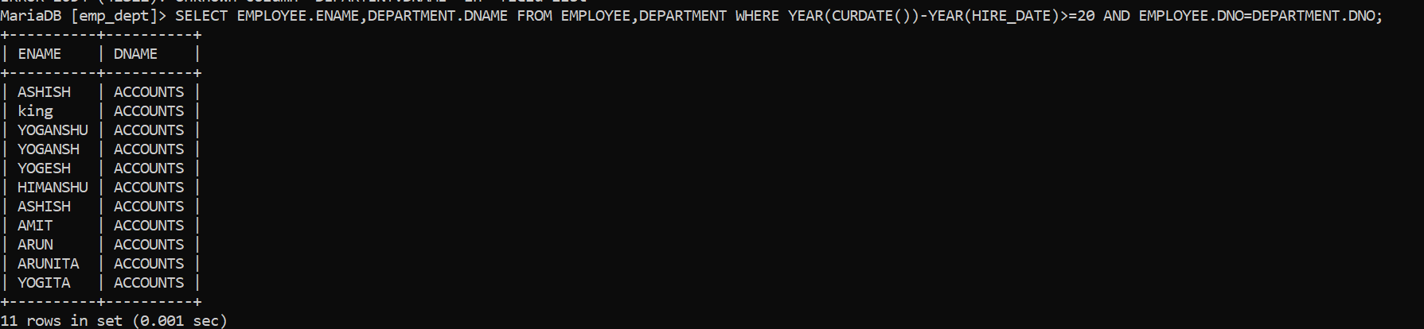

39. Display total number of departments at each location

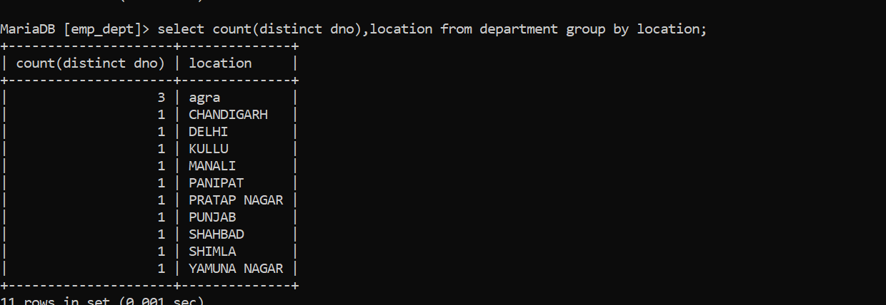

40. Find the department name in which at least 20 employees work in.

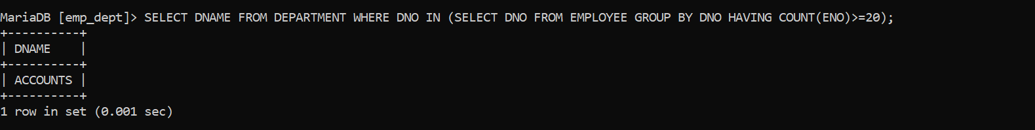

41. Query to find the employee’ name who is not supervisor and name of supervisor supervising more than 5 employees.

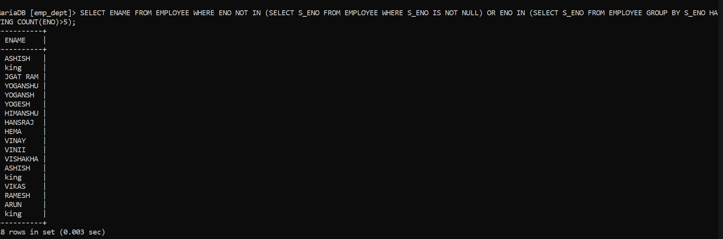

42. Query to display the job type with maximum and minimum employees

